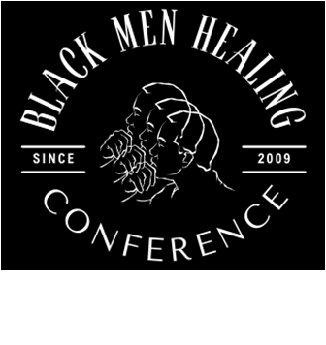 | 3033 27TH AVE S.  PO BOX 6120  MINNEAPOLIS, MN 55406  612-721-0106 | 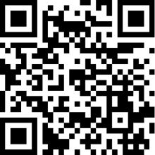
2026 CALL FOR PROPOSALS
We are seeking workshop proposals for the 18th Annual Community Empowerment Through Black Men Healing Conference, to be held on Thursday, June 25, and Friday, June 26, 2026, at St. Paul College. This year's theme is “The Mind, Body, and Soul of Community Healing”. We will critically examine the challenges that trauma poses to the mental, physical, and spiritual health of the community. Additionally, we will explore culturally sensitive, trauma-informed approaches that emphasize social connections, cultural practices, transformation, and community healing.

This conference has been called "Groundbreaking and Visionary" since the 1st conference. The goal has been to provide an opportunity for meaningful community engagement and access to national and local educators and community practitioners to discuss and introduce practical, culturally sensitive trauma-informed initiatives. That could improve the health and wellness of African American men and their families. We recognize that a thriving African American community improves the health of the community and society as a whole.

“If you never heal from what hurt you, you’ll bleed on people that didn’t cut you!”

We are seeking submissions that will provide conference attendees with the best culturally competent and community-based strategies on the following topics:

MIND
- Self-Care  - Male Trauma | - Family: Generational Trauma  - Mindfulness Practices | - Safe Community Environments  - Mental and Emotional Health

BODY
- Body-Self Care  - Nutrition | - Chronic Pain  - Prostate Cancer | - Healthcare Advocacy  - Addressing Toxic Stress

Soul/Spirit
- Breath Work  - Grief And Loss | - Generational Trauma  - Mind-Male Programming | - Role of the Faith Community  - Healthy/Non-Violent Relationships

ADDITIONAL TOPICS AND PROFESSIONALS
- Mentoring  - Chiropractors  - Job Readiness  - Gender Issues  - Medical Doctors  - Male Programming  - Massage Therapists | - Multi-generational Healing  - Early Childhood Development  - Faith-Rooted Healing Beyond the Church Walls: Engaging men through informal spiritual spaces (gyms, barbershops, kitchens, etc.) | - Online Violence, Cyber-Bullying  - Economic Trauma Healing  - Professional Self-Care and/or Healing  - State and local efforts to create culturally sensitive trauma-informed systems

Note: Open to presentations on other topics related to trauma awareness, healing, resilience, and policy change.
2026 CALL FOR PROPOSALS
Please read and complete the following form carefully.

Speaker Responsibilities
- You will need to be available on Thursday, June 25^{th,} at 10:30 or 1 pm (these are approximate times)
- Supply a laptop and/or the presentation on a flash drive.
- To provide an electronic PDF copy of the handout materials by June 15, 2026, for posting on the conference website for attendees to download. Or you can supply hard copies and make at least 40 to accommodate attendees on the workshop day.
- Speakers may promote their book but not sell or promote other products during workshop time. Workshops are strictly educational.

Speaker Benefits
- We will provide one free conference registration for you and one co-presenter, including meals.
- We will promote the workshop and its presenters through the website and other promotional channels.
- We will provide (1) screen and (1) LCD Projector for each workshop. Additional equipment will be at the presenter’s expense.

Please indicate if there will be a co-presenter
Please indicate if this will be a panel. Panels should be limited to 4, which includes you. (add panelist’s contact information below).
- Name:
 | Job Title/Professional:
 | Organization Name:
 | Phone: |  |  |  |  |  |  |  |  |  | Cell Phone:
 | E-mail:
 |  | Title of Proposed Workshop and brief description (limit of 1.5 hrs.): Please attach a bio for yourself.
 |  | List (a) the goals and objectives of your workshop and (b) the expected outcomes for participants.
 |  | Please attach a bio for yourself.
 |  | Indicate your audio-visual and other workshop equipment needs.

Co-presenters
Name: |  |  | E-mail:

Please attach a bio.

Name: |  | E-mail:

Please attach a bio.

Submit your proposal and all questions to Sam Simmons at ssc@comcast.net by the March 16, 2026, deadline. Notification will be sent to the Primary presenter by March 27, 2026. Information about the conference is available at www.brothershealing.com. Submit your proposal Now!
Panelists Information
Name: |  |  | E-mail:

Please attach a bio.

Name: |  | E-mail:

Please attach a bio.

Name: |  | E-mail:

Please attach a bio.

Name: |  | E-mail:

Please attach a bio.

