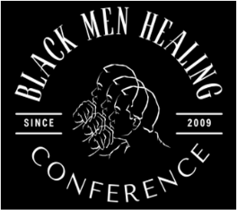 | 3033 27TH AVE S.  PO BOX 6120  MINNEAPOLIS, MN 55406  612-721-0106 | 
Sponsorship Form
Sponsor Information: (Please print or type.)
Organization Name
Contact Name
Phone |  |  |  |  | Email

Please Select Sponsorship Level
 | Level | Description |  | Fee
 | Diamond | This sponsorship includes your logo linked on our website, public recognition as a major sponsor in all conference materials, twenty-five (25) registrations, and a display table. # |  | $20,000+
 | Platinum | This sponsorship includes your organization’s logo linked on our website, public recognition as a sponsor of a workshop or speaker in conference materials, fifteen (15) registrations, and a display table. # |  | $10000+
 | Gold | This sponsorship includes your organization’s logo linked on our website, public recognition as a sponsor, ten (10) registrations, and a display table. # |  | $5000
 | Silver | This sponsorship includes your organization’s logo linked on our website, six (6) registrations, and a display table. # |  | $3500
 | Copper | This sponsorship includes your organization’s logo on the website and four (4) registrations. # |  | $2500
 | Bronze | This sponsorship includes your organization’s logo on the website and two (2) registrations. |  | $1500
 | Display Table |  | This includes a table and two chairs. # | $450
Send logos via email in .jpg or. tiff format to: ssc@comcast.net Total Amount
# Sponsors, check here if you want a display table included in the sponsorship. (# A limited number of display tables will be available on a first-come, first-served basis.)

If you are only interested in having a display table, contact us at the email address below.

Completing this form, email to ssc@comcast.net. Make checks to:

Samuel Simmons CONSULTING
3442 25th Ave. S Minneapolis, MN 55406
For more information, 612-721-0106 or www.brothershealing.com

